**December 3, 2024**

[](http://www.multifamilypress.com/)

SIMS & ASSOCIATES, INC.

<https://www.multifamilypress.com/categories/new-construction-and-development/5366-new-affordable-multifamily-mixed-use-condo-in-the-heart-of-harlem-to-bring-home-ownership-opportunities>

**New Affordable Multifamily Mixed-Use Condo in the Heart of Harlem to Bring Home Ownership Opportunities**

A 73-unit affordable mixed-use condominium will be constructed at 132 East 125 Street at Lexington Avenue, bringing home ownership opportunities to the heart of Harlem.

[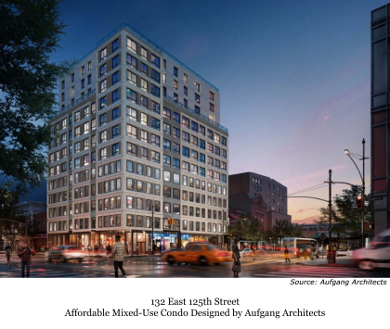](https://www.multifamilypress.com/media/k2/items/cache/c8dc88d636b01c8bbad9bc695659b1eb_XL.jpg)

Developed by Maddd Equities and designed by Aufgang Architects, the 13-story building will include 7,000 square feet of ground floor retail space and 45,000 square feet of medical offices on the second through fifth floors.

"We are pleased to enable affordable home ownership at one of the most vital intersections in Harlem," said Ariel Aufgang, Principal of Aufgang Architects. “Homeownership strengthens the economic and social fabric of communities.”

"The new condo will feature larger apartments than usually found in new affordable residential construction in Manhattan, as well as an array of energy saving and environmentally sustainable features," said Aufgang. “The new Harlem condo will provide residents with many appealing amenities.”

Of the 73 condo units, 31 will be 1-bedroom, 38 will be 2-bedroom and 4 3-bedroom units.

The development will meet HPD Homeownership Program guidelines for affordable condos, which calls for larger units than other programs. The units will be approximately 100 square feet larger than other HPD affordable programs.

Key features include:

--The building will be all electric, in compliance with Enterprise Green Communities criteria.

--Outdoor recreation space along with a fitness center and co-working space/lounge.

--Residents' quiet enjoyment of their homes will be enhanced by the installation of window/wall noise attenuation materials and alternate means of ventilation.

“The anticipated approval of the City of Yes, providing measures to develop additional affordable housing throughout the City, underscores the importance of first in class affordable homeownership, such as this multifamily project in Harlem,” said Aufgang.

In the past 22 years Aufgang Architects has designed more than 14,000 units of affordable housing and 20 million square feet of built space.

Aufgang Architects is a certified Minority Business Enterprise.